**Local Cluster Management**

To get the instances of application servers in cluster, there are some required settings and pointes to keep in mind. For cluster management you should follow a simple approach which is given below step by step.

* Get the instances of application server in tcc.
* Get the instances of application server in SMC.
* Every webadapter should have capability to route the request on all application server instance.

If these three steps are completed and tested. It means your servers are in cluster.

**Application servers in tcc**

The Tomcat Cluster Console (TCC) is an instrument to control an Intershop application cluster. This tool is able to spawn new virtual application servers and start, stop, restart single instances of application servers.

NOTE: x is used as placeholder in this document

To make it easily understandable this task is divided into three major points given below.

1. To get instances of application server in tcc, IS_TCM_SHARED variable in intershop.properties (eserver<x>/intershop.properties) of each eserver<x> must point towards same location.
2. Cluster ID(/eserver<x>/share/system/tcm/config/cluster.id) of each eserver<x> must be same.
3. If the instances of application servers are on different physical machines, Then the ip address in hosts(etc/hosts) file should be changed from default address(127.0.0.1) to the ip of your machine. For example 192.168.<x>.<xxx>.

Command to see ip of our machine ifconfig.

**If the instances are installed on a single machine**. It is recommended to make a global /tcm directory in root directory so that it is easy for all eserver<x> to point that global /tcm. Then create a group (example: isgrp) which should have all the isas<x> and iswa<x> users. Now assign this group to /tcm by command **chown**. The permissions of global /tcm should be 770. Command to change permission chmod 770 /tcm.

**If the instances are installed on a different physical machines connected through LAN**. To point same /tcm, it is necessary one of the machines have to share /tcm folder on network and other machines must mount that folder to point same /tcm in each eserver<x> intershop.properties file (eserver<x>/intershop.properties).

Steps to share files and directories between virtual machines located on different computers.

* su root. (Login through root user)
* yum install –y rpcbind nfs –utils. (installing nfs packages)
* vi /etc/exports (register the folder which is to be shared)
* systemctl start rpcbind. (start the service)
* showmount –e. (Shows the directory’s which are shared)

To mount shared directories follow steps provided below.

* Su root. (Login through root user)
* mount 192.168.<x>.<xxx>:/<SharedFolder> /<SharedFolder> (ip address is required of the machine which is sharing the directory)

To check whether the directory has been shared successfully. Enter inside your shared folder and match the files and directories are same as you require.

Now give the path of shared directory to IS_TCM_SHARED (example:IS_TCM_SHARED=</SharedFolder>) intershop.properties (eserver<x>/intershop.p roperties) file of each eserver<x>. Make sure that the cluster IDs (/eserver<x>/share/system/tcm/config) are same for all instances. And inside the hosts (etc/hosts) file your machine ip is altered with default ip.

Below Figure 1.0 shows instances of application servers in tcc.

(url: https://192.168.<x>.<xxx>:<port>/tcc)

Figure 1.0

**Application servers in SMC**

The multicast settings in appserver.properties (eserver<x>/share/system/config/cluster/appserver.prop) of each eserver<x> should be same. If intershop.event.multicastInterface is comment out then uncomment it and give your ip address (cmd: ifconfig example 192.168.<x>.<xxx>) as value of this property.

Below Figure 1.1 and Figure 1.2 shows the compression between appserver.properties of different instances.

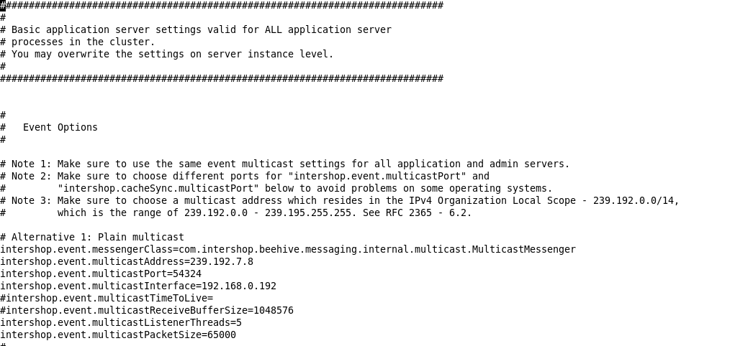Figure 1.1

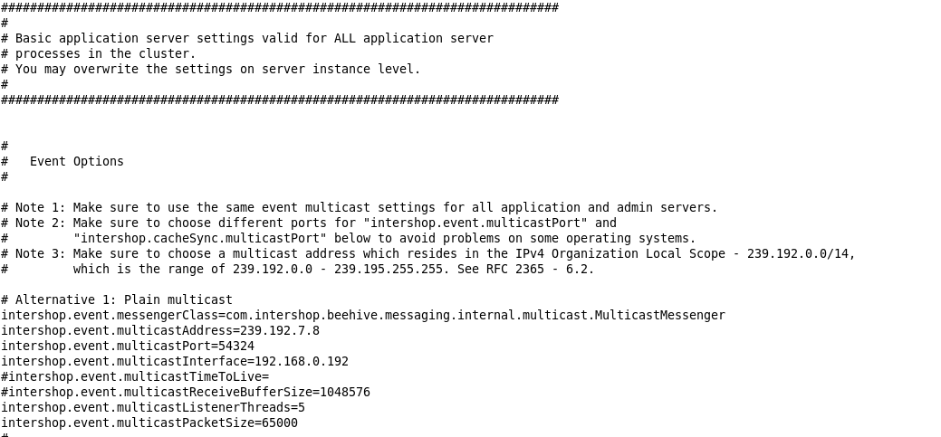Figure 1.2

Figure 1.3 shows result in SMC

Figure 1.3

**WebAdapter Confugration**

To make webadapters capable to route requests to any application server there is an important property in webadapter.properties(eserver<x>/webadapter/webadapter.properties) file. At the end of the file **Confugration Servelet** is present. Here you have to give the link of all the application server.

cs.url.0=http://192.168.<x>.<xxx>:<port>/servlet/ConfigurationServlet

This is how you have to register the link.

Below Figure 1.4 shows how to register links in Confugration Servlet of webadapter.properties file.

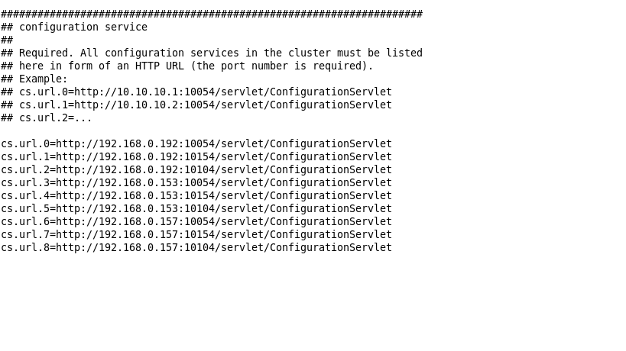Figure 1.4

**How to test if the cluster is working properly**

For example turn on eserver1 and eserver2. And open tcc of eserver1. You will see both the servers in tcc of eserver1. Now turn off eserver2. After turning eserver2 off, hit the SMC url of eserver2. If your servers are in cluster you will be able to see the login page.